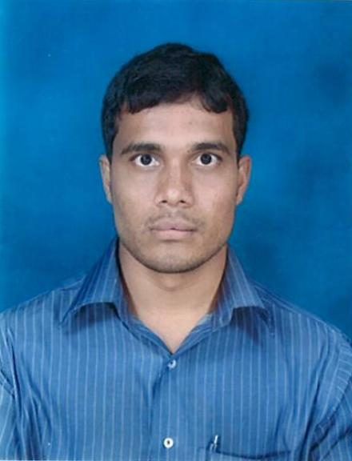**Vishwakeerthi**

**Manama, Kingdom Of Bahrain.**

**CPR No: 820646547**

**E-Mail:** [**vishwakeerthi82@gmail.com**](mailto:vishwakeerthi82@gmail.com)

**Mobile No +973-38216794**

**POST APPLIED: CASHIER**

**CAREER OBJECTIVE:**

To have a challenging position that will utilize my experience and unique abilities. A high-impact leadership position requiring creative and innovative approaches to problem solving strategy development and fulfillment of my personal goals.

**PROFESSIONAL EXPERIENCE:**

**Career Profile:**

**18th September 2009 to 25th January 2013**

**Hotel: Galleria Leela, Bangalore**

**Job Designation: Cashier.**

**10th May 2013 to 15th Feb 2014**

**Hotel: Gulf Gate, Manama**

**Kingdom of Bahrain**

**Job Designation: Cashier.**

**Duties & Responsibilities:**

* Receive payment by cash, check, credit cards, vouchers, or automatic debits.
* Issue receipts, refunds, credits, or change due to customers.
* Count money in cash drawers at the beginning of shifts to ensure that amounts are correct and that there is adequate change.
* Greet customers entering establishments.
* Maintain clean and orderly checkout areas.
* Issue trading stamps, and redeem food stamps and coupons.
* Resolve customer complaints. Answer customers' questions, and provide information on procedures or policies. Cash checks for customers.
* Calculate total payments received during a time period, and reconcile this with total sales.
* Compute and record totals of transactions. Sell tickets and other items to customers.
* Keep periodic balance sheets of amounts and numbers of transactions. Sort, count, and wrap currency and coins. Post charges against guests accounts.

**2nd March 2014 to Till Date**

**Hotel Florida PGS Group**

**Manama, Kingdom of Bahrain**

**Working as an Outlet Cashier & Outlet Supervisor.**

* Providing customer service, operated cash register, maintained a clean work area, priced and organized merchandise.
* Effectively developed telephone communication skills and consistently met quotas
* Receive payment by cash, check, credit cards, vouchers, or automatic debits
* Count money in cash drawers at the beginning of shifts to ensure that amounts are correct and that there is adequate change.
* Establish or identify prices of goods, services or admission, and tabulate bills using calculators, cash registers, or optical price scanners.
* Answer customers' questions, and provide information on procedures or policies
* Compute and record totals of transactions
* Keep periodic balance sheets of amounts and numbers of transactions
* Process merchandise returns and exchanges.
* Pay company bills by cash, vouchers, or checks.
* may be required to assist in other areas such as shelf stocking, product display, pricing and clean-up
* Keep periodic balance sheets of amounts and numbers of transactions. Sort, count, and wrap currency and coins. Post charges against guests accounts.

**EDUCATION/ACADEMIC QUALIFICATION**

**2006: B.A graduation by Mangalore University.**

**2003: Higher Secondary Certificate** (Mangalore University-Arts Stream)

**2001: Karnataka State Certificate for secondary education.**

**SKILLS & KNOWLEDGE**

* Hard Working
* Innovative
* Good Communications Skills
* Possesses software knowledge in IDS.
* Weekly prospecting and soliciting goals.
* Ability to manage guest needs.
* Strong customer development and relationship management skills.
* Strong communication skills (verbal, listening, writing).
* Strong problem-solving skills.
* Strong customer and associate relation skills.
* Strong presentation and platform skills.
* Ability to use standard software applications and hotel systems.
* Effective decision making skills.
* Perform individual and as team player.

**ADDITIONAL INFORMATION:**

* Proficient in Microsoft Word, PowerPoint and Internet usage.
* Willing to relocate for overseas assignments.

**PERSONAL DETAILS:**

Date of Birth: 21/06/1982

Marital Status: Married

Sex: Male

Nationality: Indian

Languages Known: English, Arabic, Hindi, Kannada, Telugu, and Tamil.

**PASSPORT DETAILS:**

Passport No: S9737496

Date of Issue: 17/09/2018

Date of Expiry: 16/09/2028

Place of Issue: Bahrain

Dated: Yours Sincerely,

(Vishwakeerthi)